**Requirement for basic student entry**

* Name : Change name to first name, middle name and last name
* Mother’s name :
* Profile image : take it at left side with uploading option
* Gender – combo box male or female ( combo )
* Category – general, sebc , obc , sc , st ( combo ) , other – text box
* Blood group - a+, a-, ab+ ,ab-, b+,b-,o+,o-, other – text box
* Religion – hindu, islam ( muslim ), sikh, jain, Christian , combo
* Cast:
* Branch : change label “Branch” to “Course” – BBA, BCA
* Sem – combo – I,II,III,IV,V,VI
* Division – combo – I , II
* ID No. :
* Date of birth as per the software entry format ( to be explained to developer )
* Birth Place :
* Email :
* Password: Change label to “E-connect Password” – To be generated by password generator randomly, here to be seen only. Data entry operator can’t not change it.
* Address – address line 1 , address line 2
* City:
* Taluka:
* District:
* State –
* Zip Code:
* All the address fields should be repeated, current address and permanent address and a feature to copy from current to permanent. If a student is having current address and permanent address different, than in that case, both addresses will differ.
* Student Mobile Number : to be changed to “Mobile Number: “
* Parents Residence Number to be changed to “Residence Number:”
* Parents Mobile Number:
* Parents office number to be added
* Occupation of father to be added - COMBO
* Guardian annual income to be added
* Physically handicapped – yes or no – to be added
* Think about the fees module as it is there on the website as well – econnect student data
* Academic year to be taken from master
* Date of admission
* Enrolment form number
* PRN No.
* Name of Previous School / College – combo box
* **LAST PASSED EXAMS:-**

|  |  |  |  |  |  |  |  |  |
| --- | --- | --- | --- | --- | --- | --- | --- | --- |
| **SR.NO.** | **EXAM NAME**  **(QUALIFICATION)** | **NAME OF THE SCHOOL / COLLEGE** | **EXAM**  **SEAT NO.** | **TOTAL MARKS** | **OBTAINED MARKS** | **PERCENTAGE** | **steam** | **GRADE** |
| **(1)** |  |  |  |  |  |  |  |  |
| **(2)** |  |  |  |  |  |  |  |  |

**ATTANDANCE MODULE OF SMIT – “STUDENT ATTANDACE”**

**MENU 2 – MARK ATTANDANCE ( HOME SCREEN FOR THIS MENU IS GIVEN AT LAST PAGE )**

**Option – 1 :** Student attendance entry form:

Academic year 2016-17 ( combo)

Course BBA, BCA (combo)

Sem – combo – I,II,III,IV,V,VI

Division – combo – I , II

Default Status : Combo Box – present and absent

Date : Dateselection box- default date current system date

Refer example as per below image. Change save button to “ENTER”

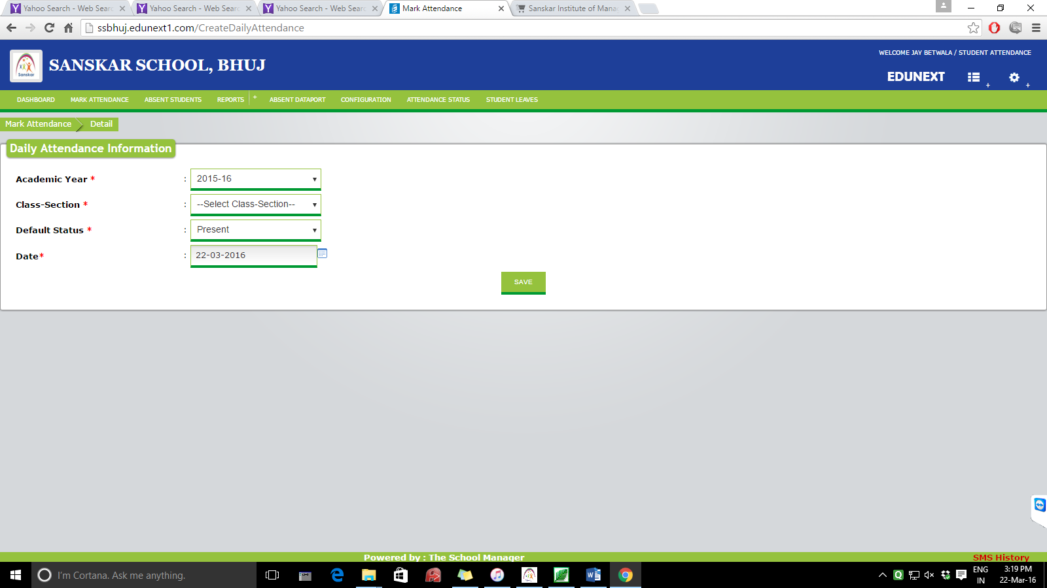

After we are entering as per above mentioned screen, next screen should be as per following image

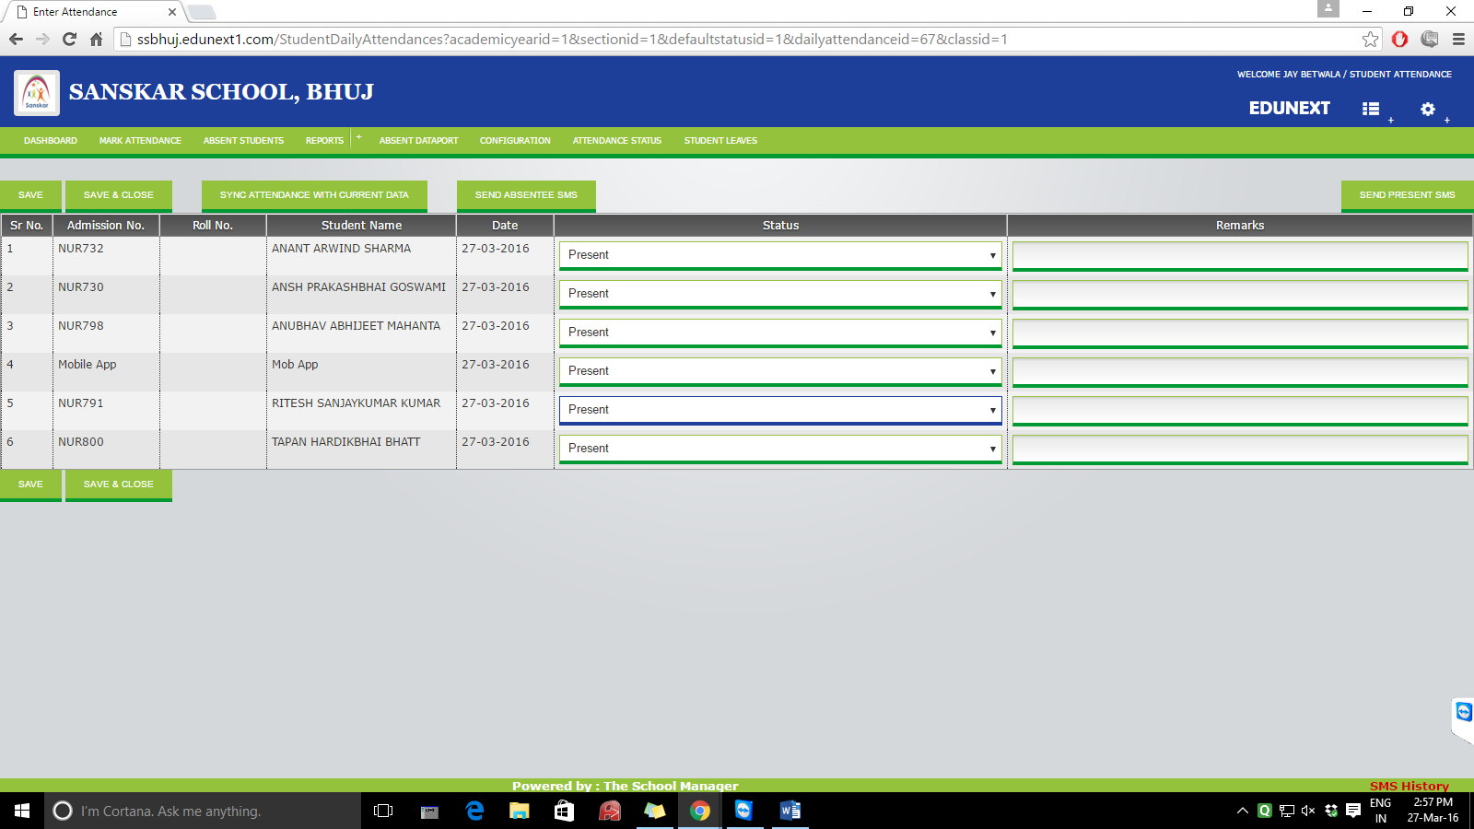

Save and Save & close button be same as above.

Save – save the data staying on the same page

Save & close – save the data and going on the back screen

Send Present / Absent SMS – SMS should be sent on parents’ mobile number

Current Date should be mentioned somewhere as a text.

Fields required in the result –

Sr.No. , I.D. No., Date of Joining, Student Name , Status , Remarks

**Option 2 -** Official Representation Attendance Entry form:(or a group of students for official representation )

Event: (text box) :

From Date: starting date

To Date: ending date

No. of Students: (e.g. is no of students are entered as 10 than at below 10 text boxes should be displayed to enter the id numbers of 10 different students. Students can be of any class and any division, we need to overwrite the existing entries in the database with the official leave)

Save

**Option 3 -**

Medical Leave Entries:

Form No.:

Student I.D.: (Text box-id no of the student whose medical leave is to be entered)

From Date:

To Date:

Name of the Dr. :

Save

**MENU 3 -** Reports :

1. **Daily attendance Report :**

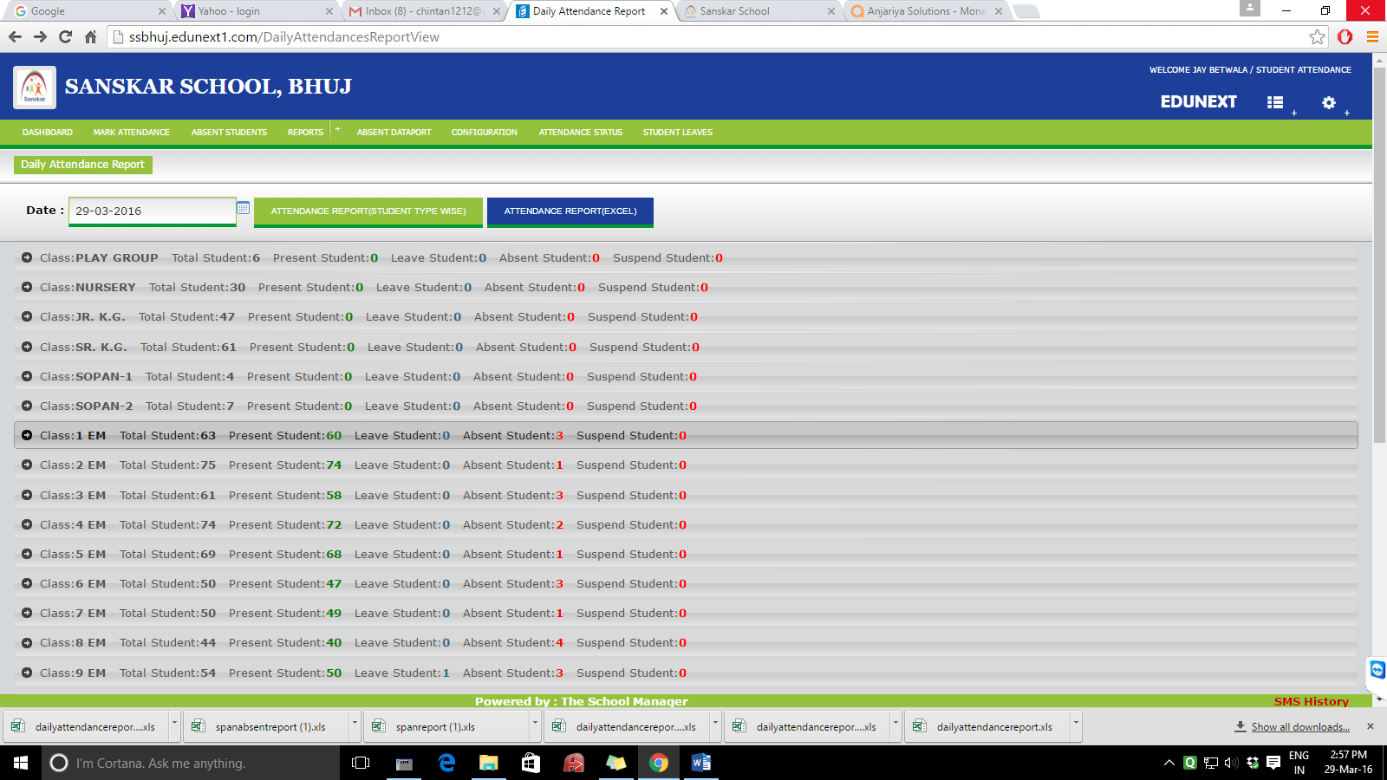

;

Date : by default Current Date

Course : Select ( COMBO ) – By Default all courses data will be displayed

In the default report as shown in grey above :

Class : Div : Total Students : Present Students : Absent Students: Official Leave Students:

Medical Leave Students:

Attendance report ( student type wise ) :

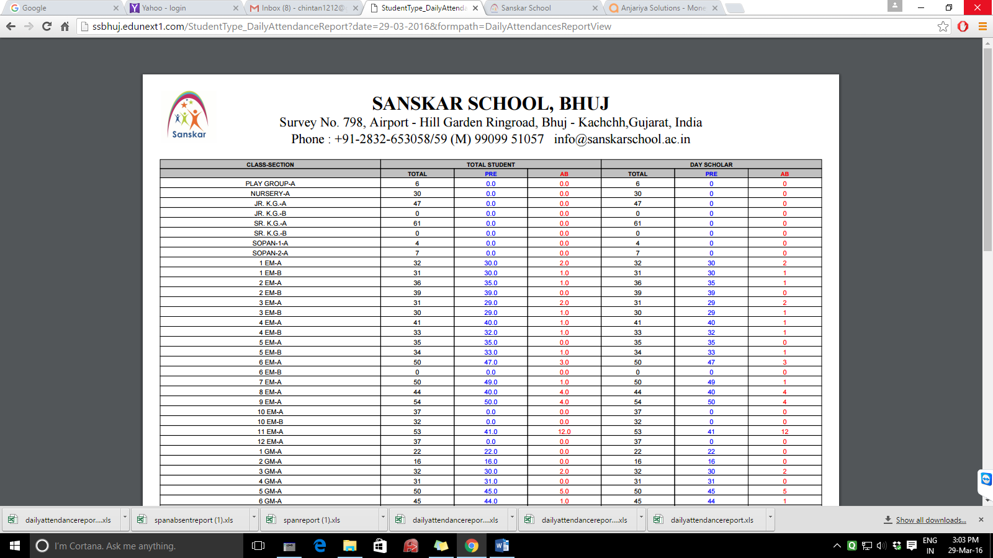

Above result modify with the titles

Class Total Students

TOTAL | PRESENT | ABSENT | O.L. | M.L.

FYBBA-1

download button should be displayed - result of the downloaded excel file shall be like this

Class Total Students

TOTAL | PRESENT | ABSENT | O.L. | M.L. | absent students name

FYBBA-1

1. **Attendance detail report**

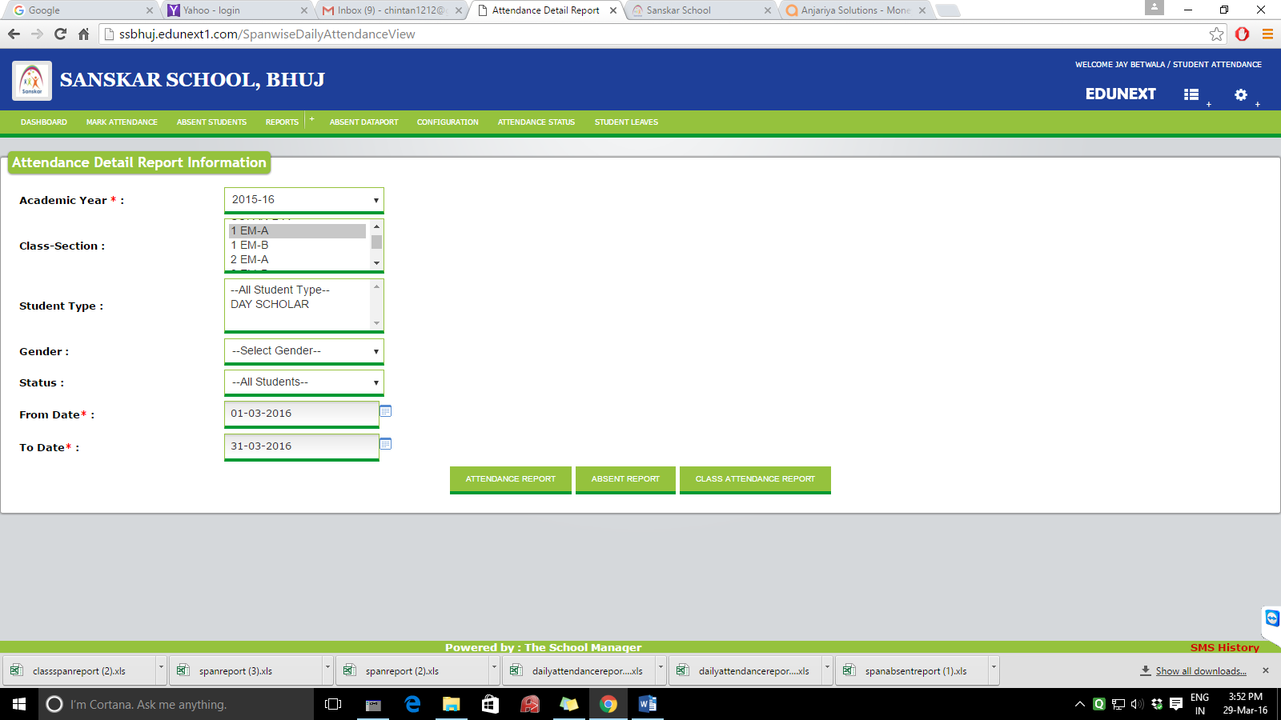

Academic year - as it is

Course : COMBO

Sem : combo

Div : combo

From date :

To date:

Percentage Cut-off - operator value these both the fields should be optional

<,<=,>,>=,=

Button 1 : **generate detailed report** for the above specified details. if in operator and value is not specified, attendance of the whole class should be getting displayed. If values are inputted than the students which are matching the above mentioned criteria, should be getting displayed. Report should be in the following format. Report should be displayed and can be downloaded also. By default the studnets will be sorted according to their id numbers. But we may sort them according to their percentage. By clicking the present% below.

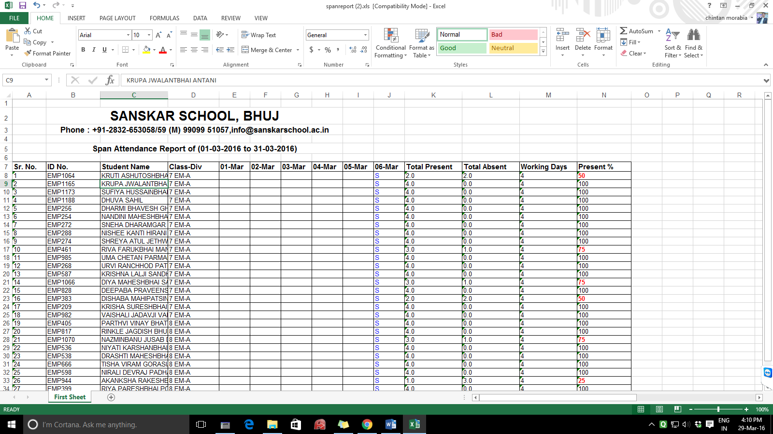

Note : official leave and medical leave should be considered as present days. Title of the report displayed as Sanskar school is to be changed.

Button 2 : **generate summary report** – same as the above report, in which dates will not be displayed. Only last four columns shall be displayed.

1. **Edit monthly attendance.**

Academic year - as it is

Month :

Course : COMBO

Sem : combo

Div : combo

Button – Edit

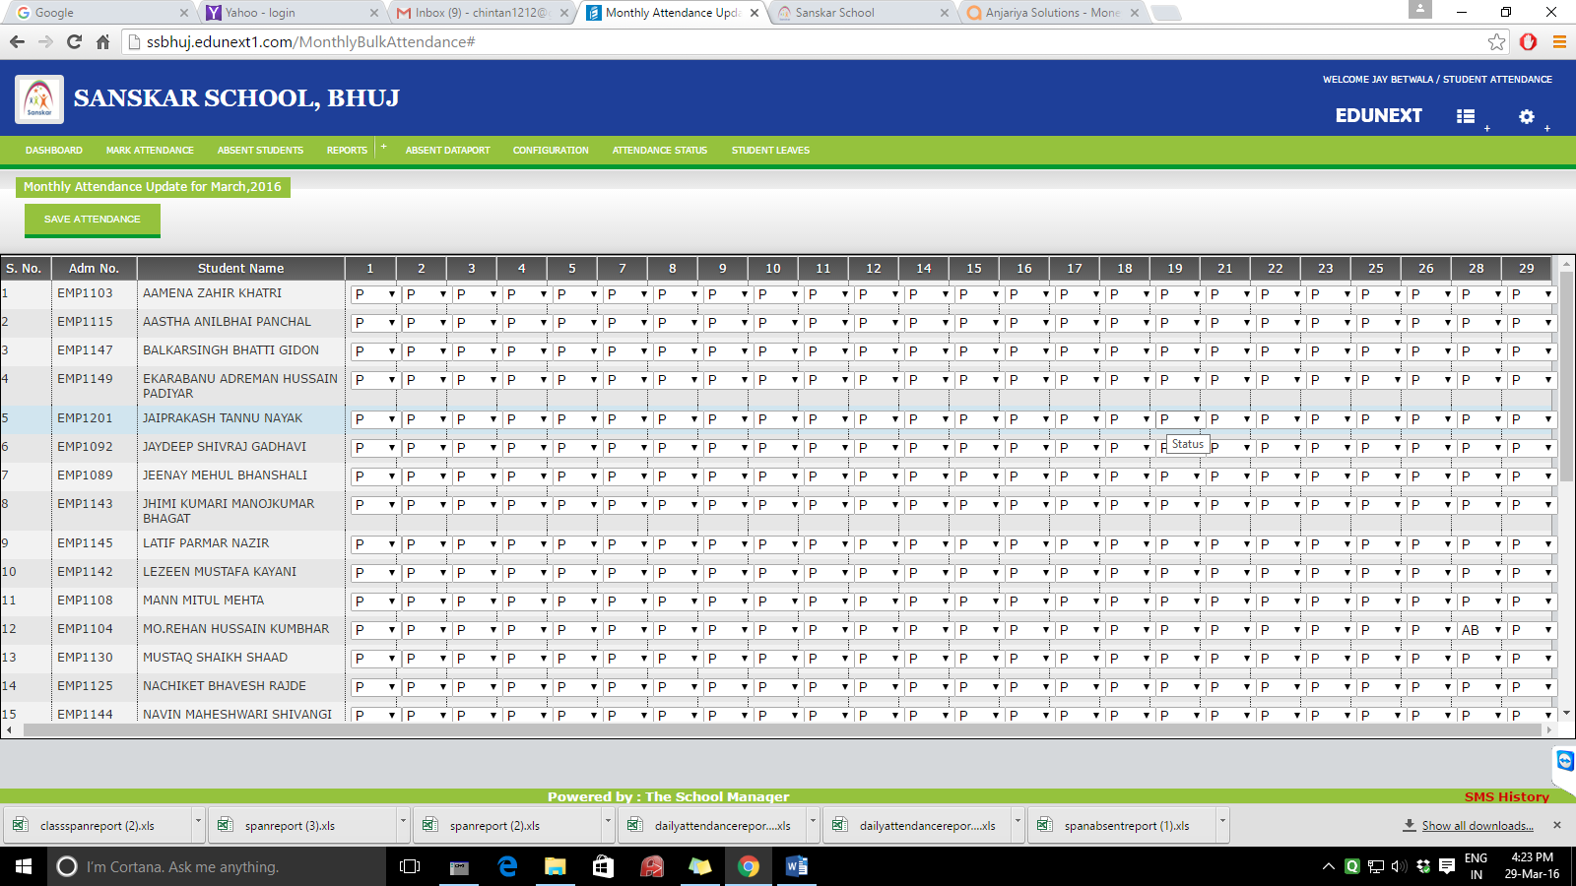

Sr. No. I.D.No. Name. Dates 1-2-3…. To current date should be displayed

Present – green , absent – red, official leave – blue , medical leave – yellow

1. **MONTHLY AVERAGE REPORT :**

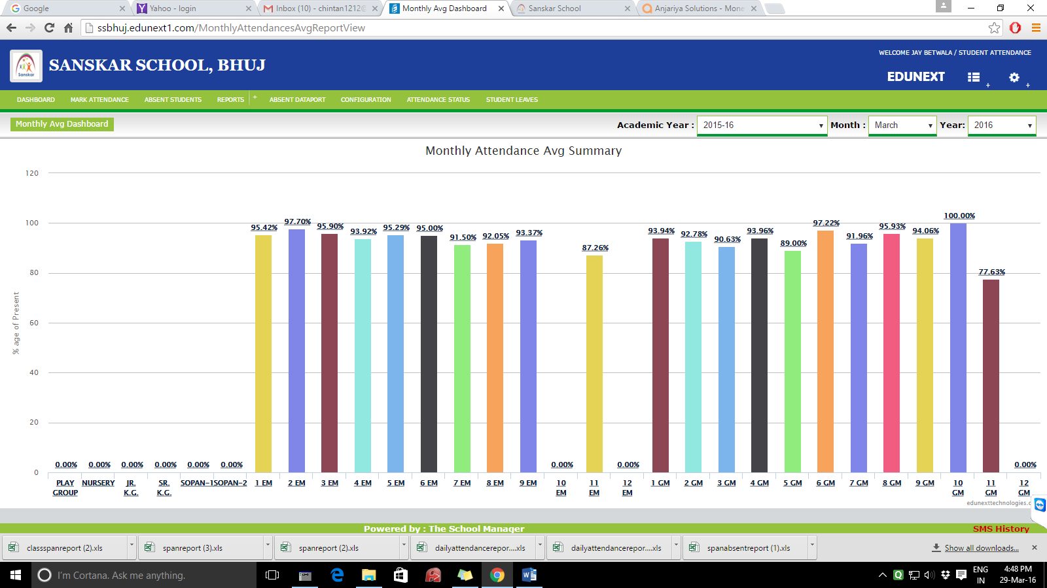

Academic year , month, year as its shown above. In addition to this, bar graphs should be including present, absent, medical leave, official leave bars as well as displayed below with four colors as mentioned before. 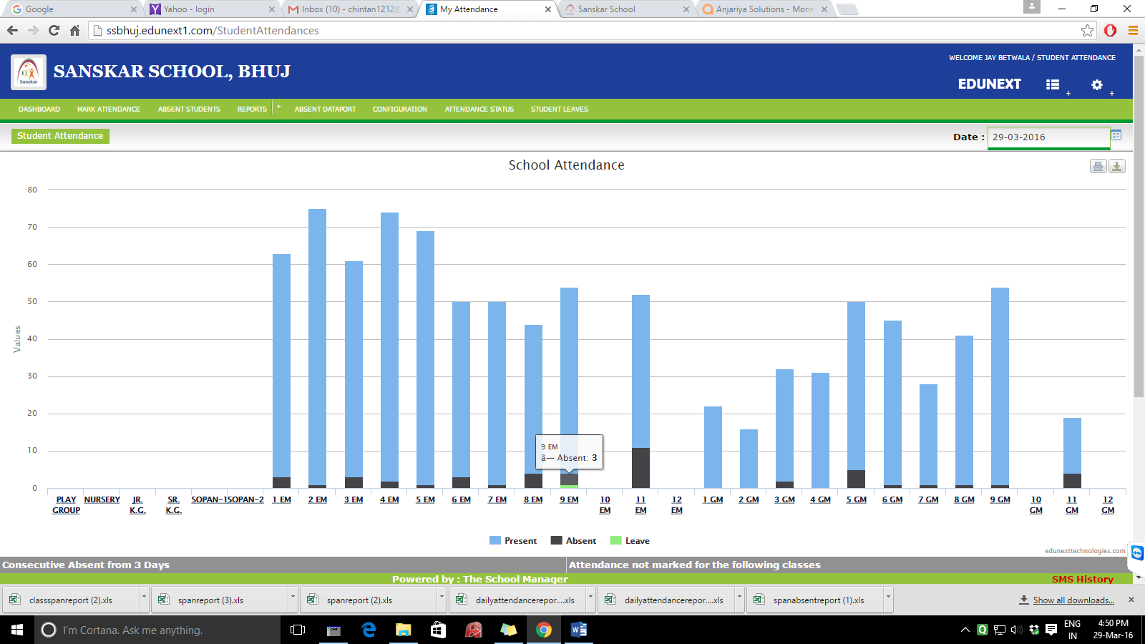

1. **Leave report :**

**Academic year :**

**From date :**

**To date :**

**Type of Leave : Medical, official**

**Button – generate report**

**Report should display the following details, can be downloaded also.**

**Sr. No. I.D. No. Name Course Semester Div. Start Date End Date Total Days**

**MENU 5-BLACKLIST**

OPTION 1 - **Library Hours and Assignment :**

Academic year - as it is

Course : COMBO

Sem : combo

Div : combo

From date :

To date:

|  |  |  |
| --- | --- | --- |
|  | Library hours | Assignments |
| 70-80 ( 70 to 76.99 ) |  |  |
| 60-70 ( 60.00 to 69.99 ) |  |  |
| 50-60 ( 50.00-59.99) |  |  |
| 40-50 ( 40.00-49.99) |  |  |
| 30-40 ( 30.00-39.99) |  |  |

**Button- generate**

**Result :**

**Sr. No. I.D. No. Name Course Semester Div. Library Hours Assignment**

**NOTE:** **In the above menu, option should be there to select multiple courses, multiple semesters and multiple divisions. The other alternate is if the three combo’s are skipped it should consider all students, and black list is generated for all students.**

**OPTION – 2 : Terminated students report**

Academic year - as it is

Course : COMBO

Sem : combo

Div : combo

From date :

To date :

Percentage :

**BUTTON1 – GENERATE REPORT BUTTON2 - GENERATE LETTER**

**Result :**

**Sr. No. I.D. No. Name Course Semester Div. total w/d total p/d percentage**

**MENU 4 : ABSENT STUDENTS REPORT**

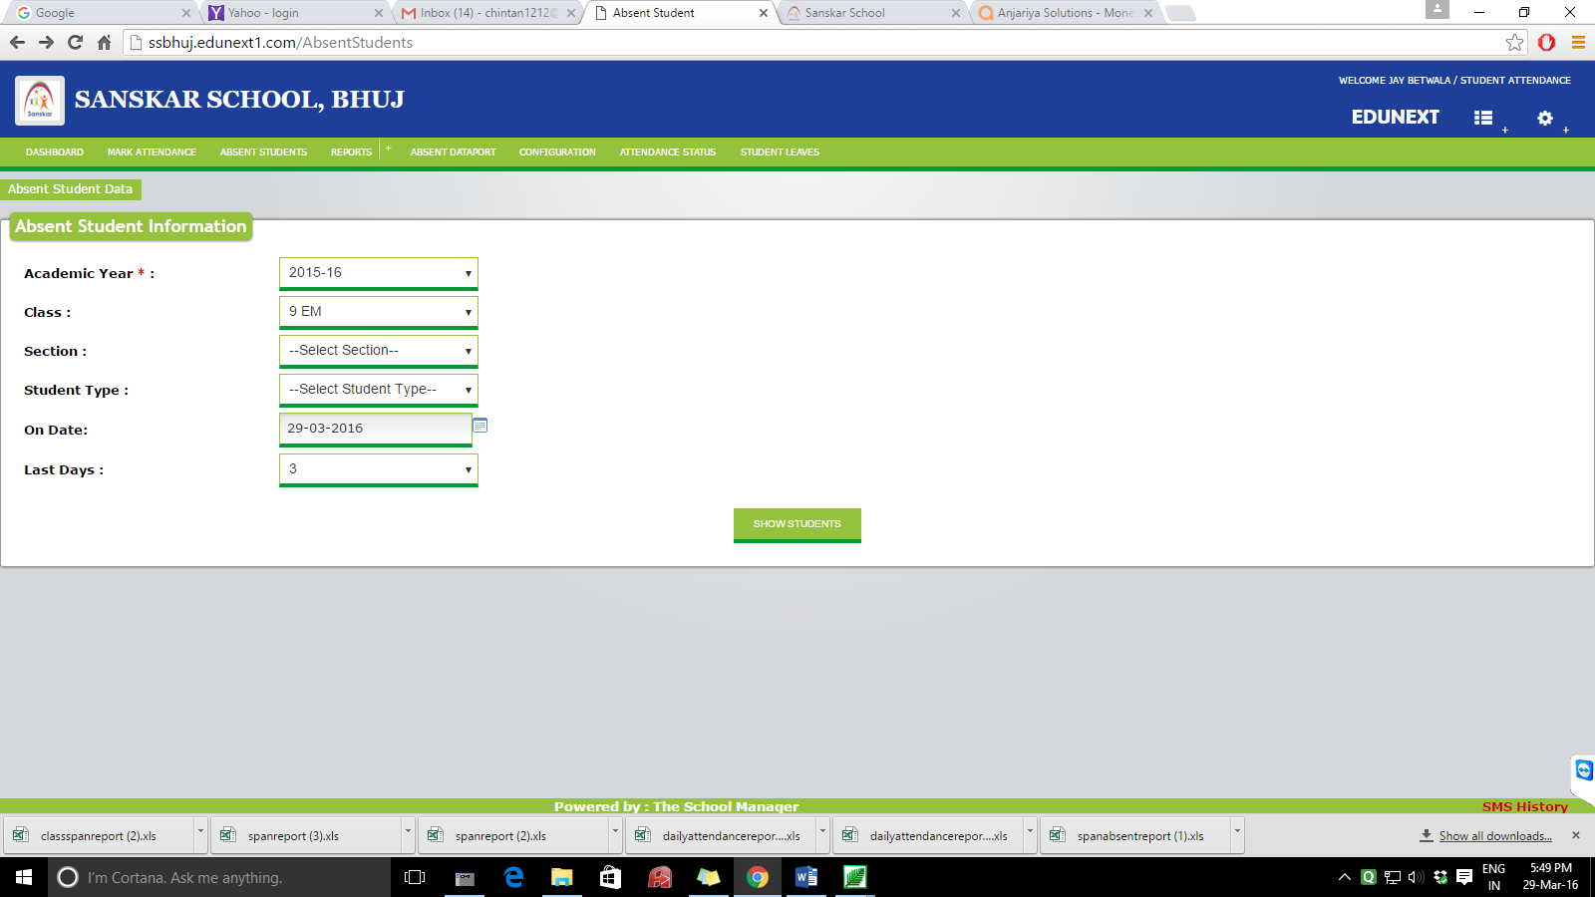

Academic year - as it is

Course : COMBO

Sem : combo

Div : combo

On date : date box – default current date

Last days : combo from last 1 to 15 days

Button – show students.

**Result –**

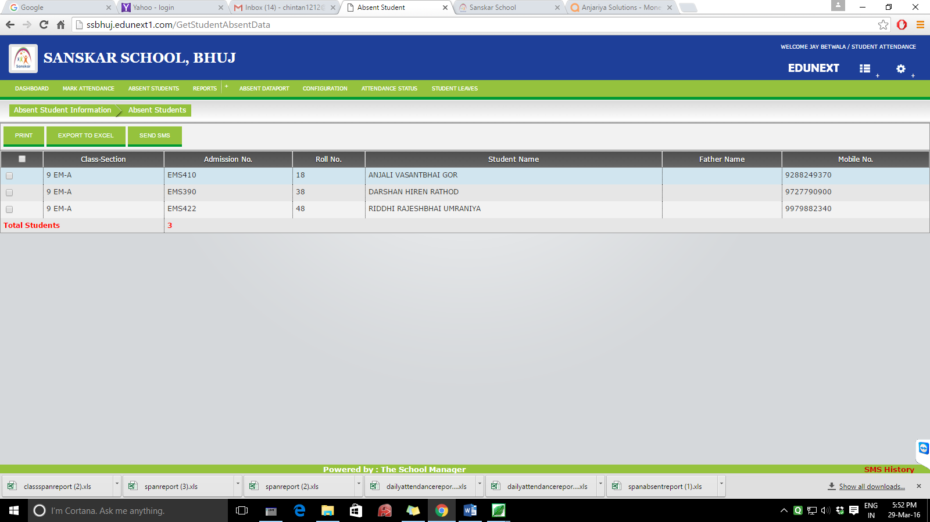

**Same type of result with the modified columns,**

**Class-div I.D. No. Student Name Parent Name Mobile No.**

**MENU1 – DASHBOARD** 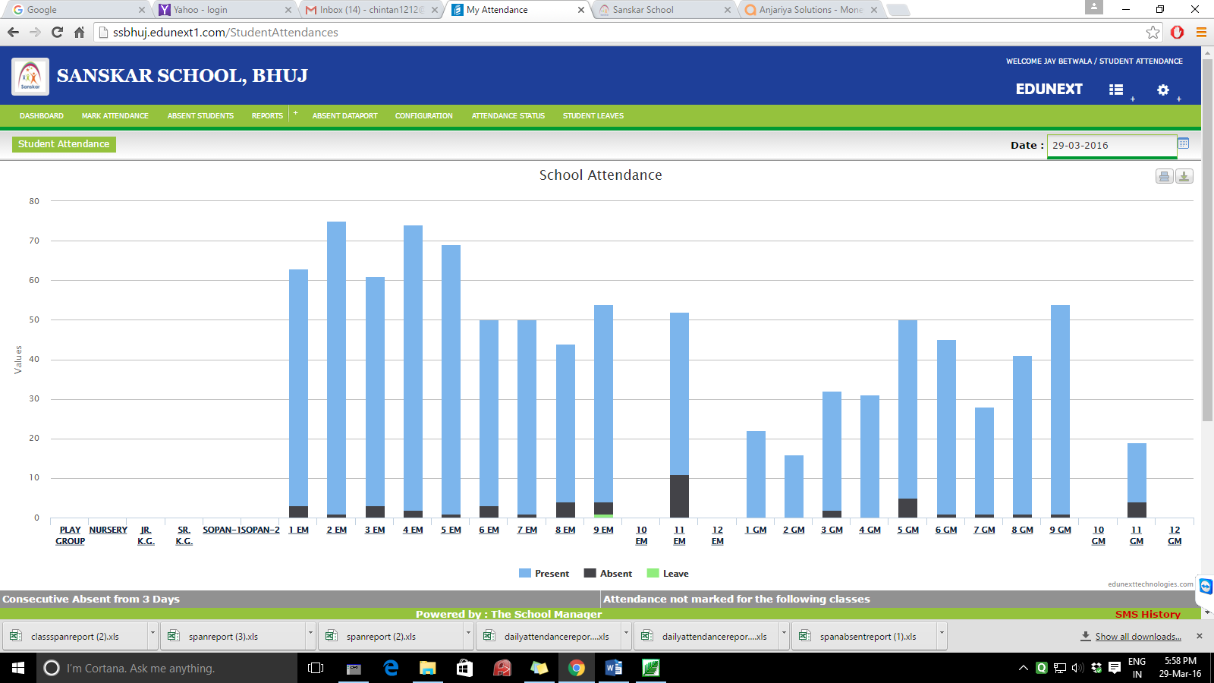

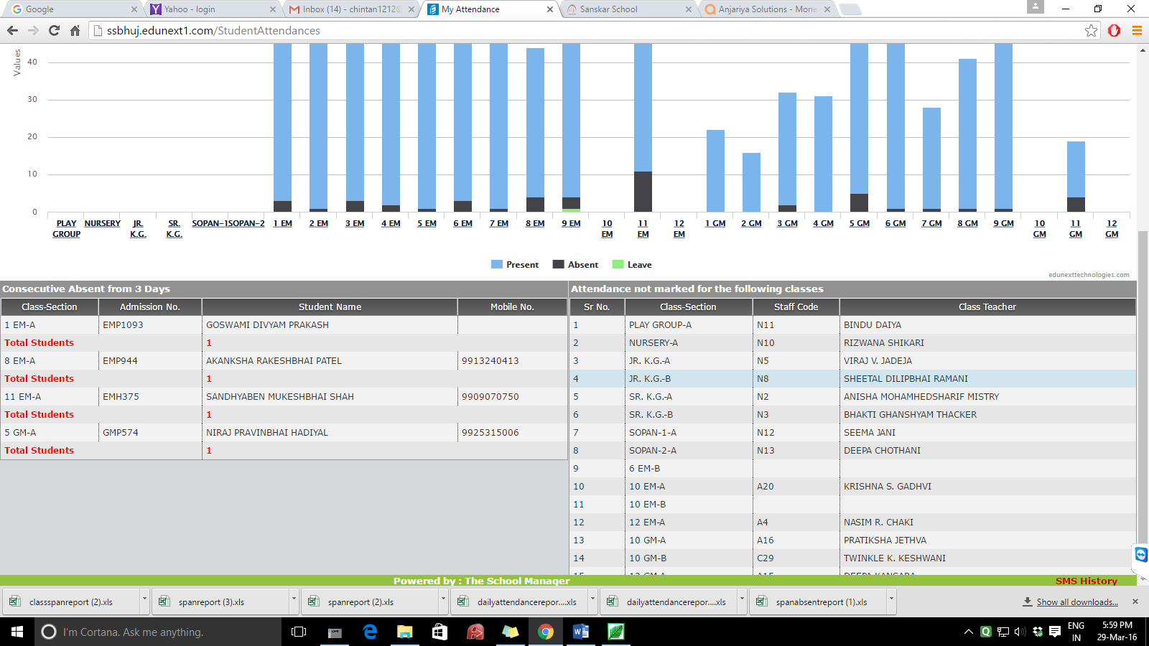

**MENU 6 : CONFIGURATION for holidays : E.G.**

FROM DATE :

TO DATE :

BUTTON 1 - POPULATE DATE

BUTTON 1 – SAVE

AFTER CLICKING POPULATE DATE, LIST WILL BE DISPLAYED FOR POPULATING HOLIDAYS, SUNDAYS SHALL BE BY DEFAULT WRITTEN AS SUNDAYS, MARKED AS - SHOULD HAVE HOLIDAY NAME TO BE WRITTEN. HOLIDAYS ONCE ENTERED CAN BE OVER WRITTEN IF EXPLICITLY ATTANDANCE IS MARKED ON HOLIDAY OR SUNDAY WITH A WARNING MESSAGE.

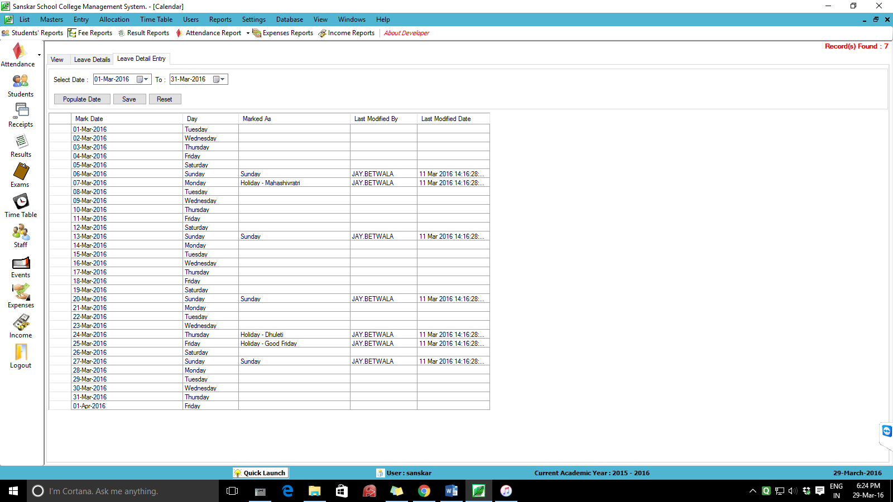

**HOME SCREEN FOR MARK ATTANDACE MENU: ( MENU 2 )**

